This document presents different games all of which I would be thrilled to run. The order they are presented in somewhat represents my interest in them. It’s your job to find those you’d be interested in playing. Common for all of these is that they will be **themed,** meaning all PCs will be linked together somehow (e.g., are all kids in a gang, family, cult members etc). Once we have figured out the campaign, we’ll find an awesome theme!

Please vote for campaigns here. In the ideal case we’ll pick a game where everyone gave a score of 4 or five. A score of 1 means you won’t play the game and if even one person a game a score of 1, we won’t choose that game. Do not hesitate to give a game a low score, that’s why they are an option!

# 2095 Cyberpunk Copenhagen with magic, the occult, and devils

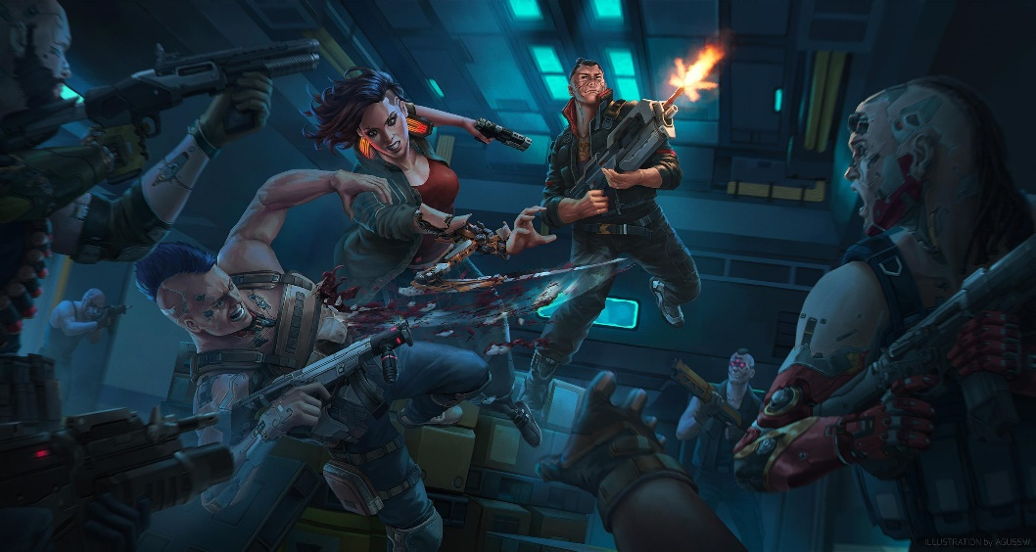*The world is neon and dust.*

*There is nothing more than the flesh. There is nothing greater than the wires. There is nothing to dream that is not sold and nothing to worship that is not made. It is a mirrorshade world of human reflections, every red hunger and every black passion worshiped in cathedrals of glass and greed. The great love their sins like children and the least want only to be great. Who could hope for more?*

**City Sandbox.**  
**Politics**: Medium  
**Roleplaying**: Low-medium.  
**Tactics**: Medium (Dangerous)  
**System**: OSC (Cities Without Number, Very D&D like)  
**Adventure length**: 1-2 sessions

**Player Buy-in**Players are highly self-directed, and PCs absolutely need to have individual goals, whether to get rich or die trying, or to take bloody revenge on the corp that wronged them, or to make some haven of humanity within a hellishly commoditized world. The world will be highly reactive, and the type of games (Heist, shootdown, dungeon crawl etc) will depend on your goals.

# How to Play Vaesen: Nordic Horror Roleplaying - Tabletop GamingNordic 19th Century Mythic Horror

*In dark forests, beyond the mountains, by black lakes in hidden groves. At your doorstep. In the shadows, something stirs. Strange beings. Twisted creatures, lurking at the edge of vision. Watching. Waiting. Unseen by most, but not by you. You see them for what they really are. Vaesen.*

*Welcome to the Mythic North – northern Europe of the nineteenth century, but not as we know it today. A land where the myths are real. A cold reach covered by vast forests, its few cities lonely beacons of industry and enlightenment – a new civilization dawning. But in the countryside, the old ways still hold sway. There, people know what lurks in the dark.*

*They know to fear it.*

**Mystery Horror**  
**Politics**: Low  
**Roleplaying**: Very High  
**Tactics**: Low (Dangerous)  
**System**: Vaesen (Year Zero Engine, Easy to learn)  
**Adventure length**: 1-2 sessions

**Player Buy-in**Linear set of mysteries with no overarching plot. Big focus on PC personality and background, and the game won’t work with one dimensional PCs. Facing personal dilemmas while solving supernatural mysteries must sound fun. Will include adult themes.

# Radical Remix of Descent into Avernus

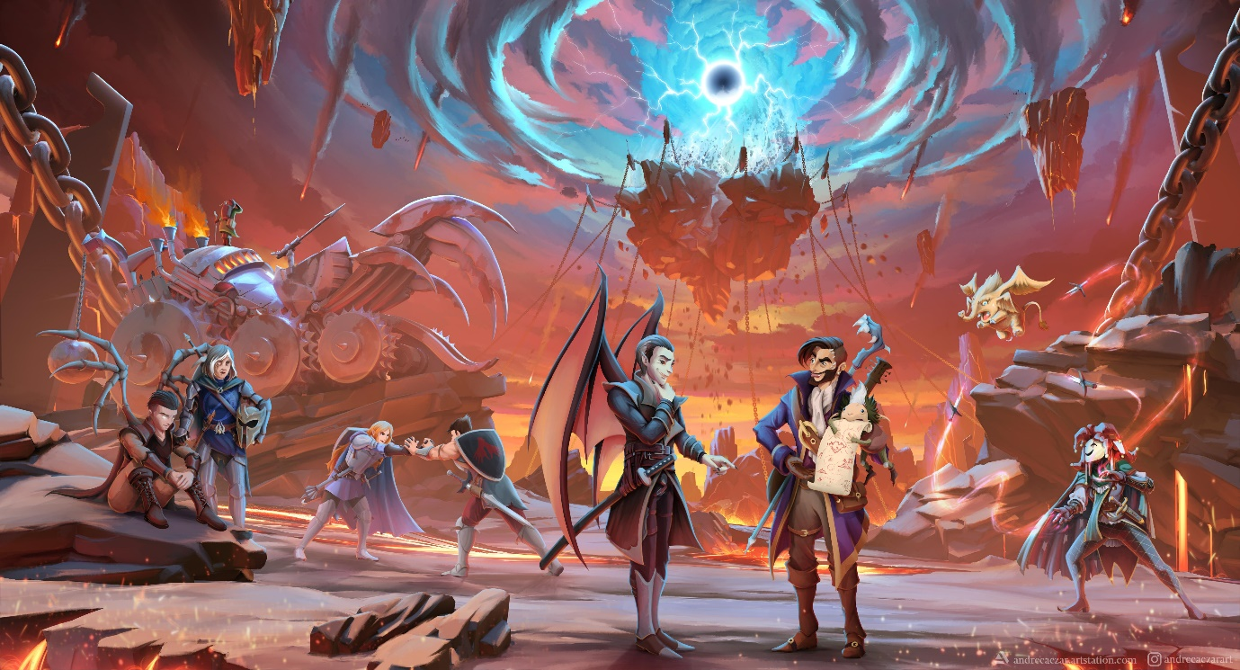*Welcome to Baldur's Gate, a city of ambition and corruption. You’ve just started your adventuring career, but already find yourself embroiled in a plot that sprawls from the shadows of Baldur's Gate to the front lines of the planes-spanning Blood War! Do you have what it takes to turn infernal war machines and nefarious contracts against the archdevil Zariel and her diabolical hordes? And can you ever hope to find your way home safely when pitted against the infinite evils of the Nine Hells?*

**Heroic High fantasy**  
**Politics**: Low-Medium  
**Roleplaying**: Low-Medium   
**Tactics**: High (Low lethality)  
**System**: D&D 5e with moderate homebrew changes  
**Adventure length**: Campaign play

**Player Buy-in**You’ll be experience Hell and its many vices in this heroic high fantasy classical d&d 5e campaign play experience. It will be similar in many ways to our previous game, except this one has an overarching plot. The most combat oriented game.

# A drawing of a person in armor Description automatically generatedExploring a post-apocalyptic medieval kingdom

*In this open-world survival roleplaying game, you’re not heroes sent on missions dictated by others - instead, you are raiders and rogues bent on making your own mark on a cursed world. You will discover lost tombs, fight terrible monsters, wander the wild lands and, if you live long enough, build your own stronghold to defend.*

**Gritty hex crawl exploration**  
**Politics**: Low  
**Roleplaying**: Low-Medium  
**Tactics**: Medium (every combat can be the last)  
**System**: Forbidden Lands (Year Zero Engine, Easy to learn)  
**Adventure length**: Campaign Play

**Player Buy-in**The whole deal is hex-exploring an apocalypse struck medieval kingdom and what’s left behind. You must enjoy hex exploration and dungeon crawling. Low fantasy with risky magic and combats which are likely to grant lasting injuries if not outright death.

# **40K Wrath & Glory - Litanies of the Lost - RPG Tabletop Games » Warhammer RPG » WH 40k RPG - The Days of Knights**The Warhammer 40k game

*In the 41st Millennium, warring factions from ancient civilisations and upstart empires fight endless battles across innumerable worlds. Humanity stands alone, beset on all sides by the heretic, the mutant, and the alien. There is no mercy. There is no respite. Prepare yourself for battle.*

***This campaign has two options:***

1. **Heroic action-adventure**

**Politics**: Low-Medium  
**Roleplaying**: Low-medium   
**Tactics**: High (Low lethality)  
**System**: Wrath and Glory  
**Adventure length**: 3-5

1. **Mystery-investigation**

**Politics**: Medium   
**Roleplaying**: High  
**Tactics**: Low (Deadly)  
**System**: Imperium Maledictum  
**Adventure length**: 2-4

**Player Buy-in**The selling point here is the setting: Warhammer 40k. You don’t need to know any lore when we begin, but if you are completely new to the setting, watch [this](https://youtu.be/_rUB4mQOAiM?si=agq8sTcNDSvdv4eh) (2 min) and [this](https://www.youtube.com/watch?v=O7hgjuFfn3A) (13 min) video. If they don’t hype you up, this is not the game for you.

# Modern supernatural extreme horror

*****Mankind is trapped in an Illusion. Held captives by our prisoners. We can not see the great citadels of Metropolis towering over our highest skyscrapers. We can not hear the screams from the cellar hidden stairs take us to. We can not smell the blood and burnt flesh from those poor souls sacrificed to long forgotten Gods, in lost alleys. We feel isolated, alone, and try out utmost to stay away from the dangers, the darkness of the city we dwell in.*

**Personal Horror**  
**Politics**: Low  
**Roleplaying**: Very High  
**Tactics**: Low (Deadly)  
**System**: Kult: Divinity Lost (Powered by the Apocalypse inspired)  
**Adventure length**: Campaign play

**Player Buy-in**You’ll delve deep into your flawed PC who is starting to see the world for what it really is. The focus is on the characters, their relationships, their mundane lives, fears, hopes as they discover everything, they’ve ever known is a lie. You won’t be a hero when you battle cultists, fallen angels and other monsters. This is not a game for everyone. It features extremely comfort-zone breaking moments, such as the following example from the book: “*At the end of the day, what constitutes a transcendental experience depends on the individual. Some subordinate themselves completely to another’s power and strive to become totally broken and objectified in order to attain ecstasy and truth in their utter vulnerability. Some inject heroin from filthy syringes in the slums of Johannesburg, while others rape minors in a luxurious hotel room in Bangkok. There are those who achieve insight as they mutilate their genitals in front of a webcam. “*